Cathy Acosta

scrum

An Introduction

Contents

Introduction 2

Scrum Pillars 2

Scrum Values 2

People, Events and Artifacts 3

The Scrum Team 3

The Product Owner (PO) 3

The Scrum Master 4

Developers 4

The SCRUM EVENTS 4

The Sprint 4

The Daily Scrum 4

The Sprint Review 4

The Sprint Retrospective 4

The Scrum Artifacts 4

The Product Backlog 4

The Product Goal 4

The Sprint Backlog 4

The Sprint Goal 4

The Increment 4

The Definition of Done 5

Bibliography 5

# Introduction

This guide pretends to be a guide with all you need to know to start working with this fantastic methodology based on Agile.

Scrum combines four formal events for inspection and adaptation within a containing event, the Sprint. These events work because they implement the empirical Scrum pillars of transparency, inspection, and adaptation (Ken Schwaber, Jeff Sutherland, 2020).

Scrum is based in 3 pillars and 5 values.

## Scrum Pillars

* **Transparency**: so, everybody in the Team can know what is going on in each Sprint.
* **Inspection**: inspection of the work done all the way and constantly, so we can detect any error sooner.
* **Adaptation**: we must be able to adapt to any change at any time of any Sprint.

## Scrum Values

* **Commitment**: commit to achieve the goals of the Scrum Team.
* **Focus**: on the work of the Sprint and the goals.
* **Openness**: The Scrum Team and the Product Owner/Stakeholders will be open about all the work and the challenges.
* **Respect**: respect each other.
* **Courage**: Have courage to do the right thing.

## People, Events and Artifacts

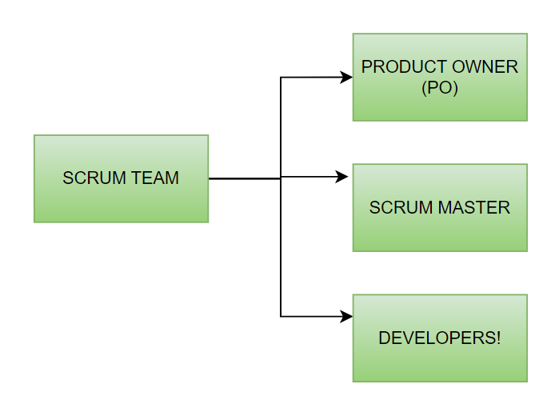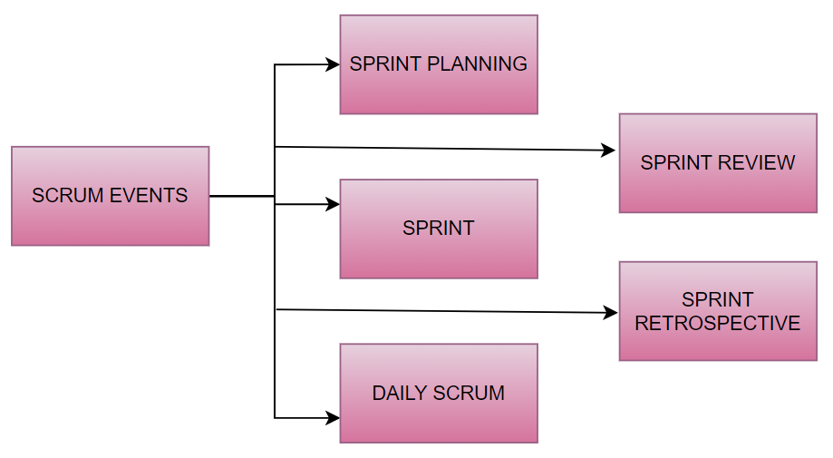

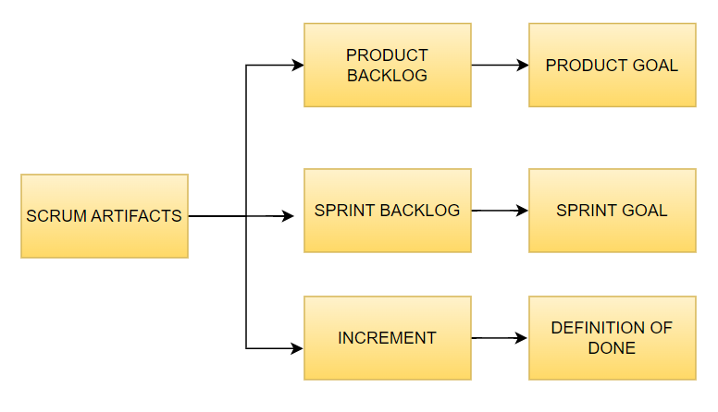

# The Scrum Team

The Product Owner (PO): represents the product’s stakeholders and the customer (or customers). The PO is the responsible for maximizing the value of the product resulting from the work of the Scrum Team (Ken Schwaber, Jeff Sutherland, 2020). He provides clarity to the team about the product’s goal and vision. He is also the main responsible to have an updated Product Backlog.

The Scrum Master: is the one responsible to exchange the information between the members of the Team (including the PO). The PO will be present in some meetings though. His purpose is to help the Team to understand the Scrum theory and practice. He will help the Scrum Team to create a high-value Increments and will ensure that all the Scrum events take place and are productive. He is also available to help the PO in case this needs it to define and manage the Product Backlog.

Developers: they will give the shape to the PO’s product. They are responsible of:

* + Create a plan for each Sprint: The Sprint Backlog.
  + Instilling quality by adhering to a Definition of Done
  + Adapting their plan each day toward the Sprint Goal
  + Holding each other accountable as professionals. (Scrum Org, s.f.)

# The SCRUM EVENTS

The Sprint: is an interval of time in where one Sprint Goal should be fulfilled. The Sprint starts with the Sprint Planning which collects what work will be done during this Sprint.

The Daily Scrum: a 15-minute daily meeting (always at the same time and in the same place) to check how all the team is going: what everyone has been doing, what everyone will do that day and if there is any barrier or difficulty found so far.

The Sprint Review: is a meeting between the PO (and sometimes the stakeholders) where the Team present the work done during that Sprint. We listen to the PO’s feedback and arrange changes in the product for the next Sprint, updating the Product Backlog (the PO and the Scrum Master do that).

The Sprint Retrospective: is a meeting within the Scrum Team which purpose is to improve the Team and make it more efficient by discussing any problem (or not a problem, just tips about how to do something better) about everything related with the Team and the project: individuals, interactions, tools, environment, Definition of Done… This is held at the end of the Sprint.

# The Scrum Artifacts

The Product Backlog: a list of all the requirements needed to successfully develop the Product the PO wants. This is a broadly list, as it will be more detailed in the

The Product Goal: this is a description of the future state of the product. Its function is to provide context to the Product Backlog.

The Sprint Backlog: The Sprint Backlog is composed of the Sprint Goal (why), the set of Product Backlog items selected for the Sprint (what), as well as an actionable plan for delivering the Increment (how) (Ken Schwaber, Jeff Sutherland, 2020).

The Sprint Goal: is the single objective for the Sprint (Ken Schwaber, Jeff Sutherland, 2020).

The Increment: is the sum of all elements from the Product Backlog that have been Done during this Spring altogether with the Increments from the past Sprints. In our case this will be the code.

The Definition of Done: formal description of the state of the Increment when it meets the quality measures required for the product (Ken Schwaber, Jeff Sutherland, 2020).

# Bibliography

Ken Schwaber, Jeff Sutherland. (2020, November). *Scrum Guide.*

Scrum Org. (n.d.). Retrieved from Scrum.org: https://www.scrum.org/learning-series/what-is-scrum/the-scrum-team/what-is-a-developer